freETarget
Application Note: Precision Calibration

INTRODUCTION
Straight out of the box, the FreeETarget circuit operates with relatively low calibration with no extra work. For those users who demand the best in accuracy, the target can be calibrated to remove errors due to assembly or other defects. This document describes the calibration and the steps needed to do this on the target.
REQUIRED EQUIPMENT
Item | Description | Required
1 | Air Pistol Target | 2 required
2 | Suis target mask | 2 required
3 | Target Scan smartphone app
4 | Notepad or similar text editor
 | Alternate if you do not have TargetScan
3A | Graph paper | 2 required
3B | Thumbtack | 1 required
THEORY OF OPERATION.
Aligning the paper needs to take care of the following sources of error
- Relative position of the paper to the sensors
- Angular orientation of the paper to the sensors
- Consistency in the location of the sensors
The calibration procedure takes care of these errors by comparing the calculated to the actual and applying a correction to each source of error.
An exaggerated sample of a paper target to the electronic target is shown in Figure 1. This shows a target with two holes (red) and two reported locations (black)
The four errors are:
- Static Position Error due to a misalignment between the paper and the sensors. This error will be consistent for each shot.
- Angular Position Error due to skew between the paper and sensors. This error will be consistent for each shot
- Radial Error, a difference between what the paper and the electronics support. This error may vary based on the position of the shot due to errors in locating the individual sensors
- Angular Position error, a difference between the location of the shot and it’s computed value. This error may be based on how the sound travels to the sensor.
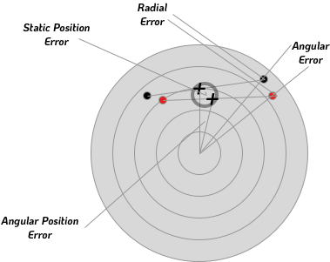
Figure 1. Target Error Sources

Static Position Error
The Static Position Error is eliminated by:
- Finding the geometric centre of the shots reported by the target
- Finding the geometric centre of the shots as recognized on the paper.
- Correcting for the difference between the two locations.
Static Angular Position Error
After shifting the shots to align the geometric centres of the actual to the paper shots, the Angular Position Error is eliminated by:
- Averaging the angular position of the actual target shots
- Averaging the angular position of the paper shots
- Adding the angular error to each new shot as it arrives.

Angular Error
The Angular Error occurs when there is a position error in the sensor that places the sensor out-of-round. This will skew the shots so that they appear uneven. The Angular Error is corrected by starting with a sample of (say) ten shots that can be compared between actual and target.
- Divide the circle of shots into arcs between the sample shots
- In each arc build a spline function that interpolates the angular difference between the two shots.
- As each shot arrives, determine which arc the new shots belongs to
- Determine the angular error and add it to the angular displacement of each new shot

Radial Error
The Radial Error occurs when the position error of the sensor is out of round and skews the shots so that they appear in an oval. Much the same as the Angular Error, the Radial Error is corrected by
- Divide the circle of shots into arcs between the sample shots.
- Correct each sample shot for the angular error calculated above
- For each arc, build a spline function that interpolates the ratio (scale factor) between the actual and target shots.
- As each new shot arrives, determine which arch the shots belongs to
- Multiply the computed radial displacement by the spline computed scaling factor

CALIBRATION PROCEDURE
The calibration procedure is done in the following steps:
- {“CAL”:1} -Prepare to calibrate the target
- Take twenty (20) sample shots
- {“CAL”:2} – Enter the reference data into the target
All of these steps can be carried out using the debug tab on the PC client.
Prepare the Calibration
Start by carefully locating the centre of the two paper target in the centre of two Suis mask.s as shown in Figure 1. It is important that this be done precisely since an error here will translate into the final calibration.

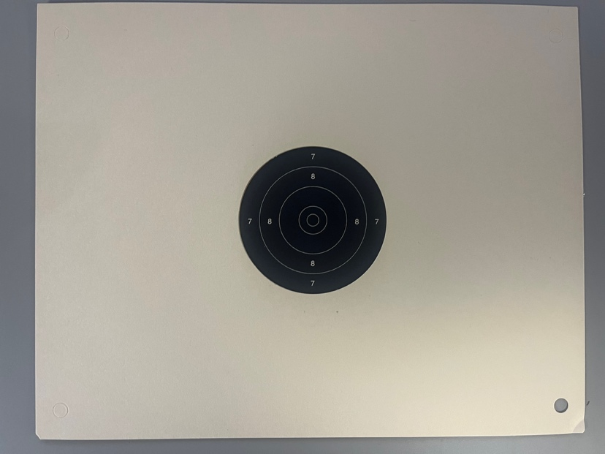
Figure 1: Target and Mask Assembly

On the PC with the Client
- Open the PC client
- Connect to the target
- Press the Debug tab to observe the target as you shoot
- Send the command {“CAL”:1} to the target. This removes the current calibration and prepares the software to accept the data.

Take Twenty Sample Shots
Take twenty sample shots. Ideally the shots need to land in a circle in the four ring. As shown in Figure 2, you want to spead the shots out across the target as much as possible.
DO NOT EXIT THE PC CLIENT UNTIL CALIBRATION IS COMPLETE, OTHERWISE THE SHOT DATA WILL BE LOST.

Importing the Target Reference Data
Using the upload icon at the bottom of the Target Scan Page (lower left square with an up arrow) email the Shots Data to yourself (Figure 2)
The shot data is a CSV file that can be observed using Excel or some other spread sheet. The target data is shown in Figure 3.
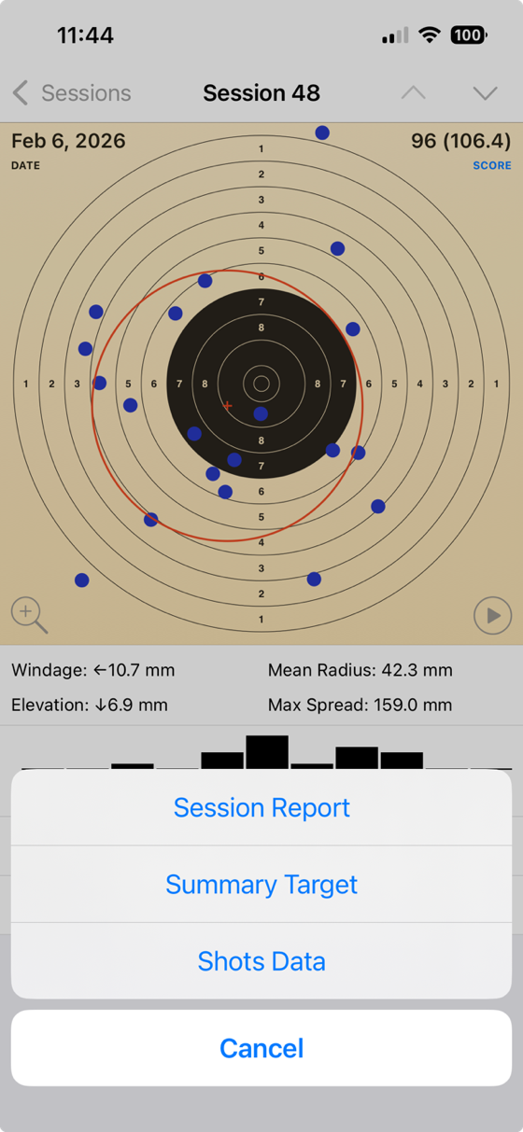  Figure 2: Sending Shots Data | 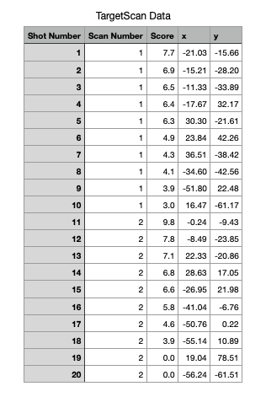  Figure 3: Target Scan Data
Calibrate the Target
Send the command {“CAL”:2} to the target using the GENERIC COMMAND box in the debug tab
The target will prompt the user to select a calibration reference.
1 - TargetScan CSV file
2- Tabulated Data
Enter mode:
Enter 1 and press SEND if using a TargetScan file, or 2 is entering the data by hand.

Figure 4: Calibration Command Line
The target will match up the target scan data to the shot data and keep the ten shots furthest way from the 10 ring. It will then generate a series of calibration constants that will be used to adjust the shots.
At the end of the calibration, you will be prompted to save the settings. Clear the command box and enter Y then send.
The target is now calibrated.
Erasing the Calibration
If you make a mistake in the calibration, you can clear the calibration by sending the command {“CAL”:8}. You will be prompted to confirm that the calibration should be cleared.

APPENDIX 1
ALTERNATE CALIBRATION METHOD
If you do not have Target Scan, you can use an alternate calibration method using graph paper.
Using a thumbtack or pin, align the centre of the target to the centre line of the graph paper as shown in Figure A1
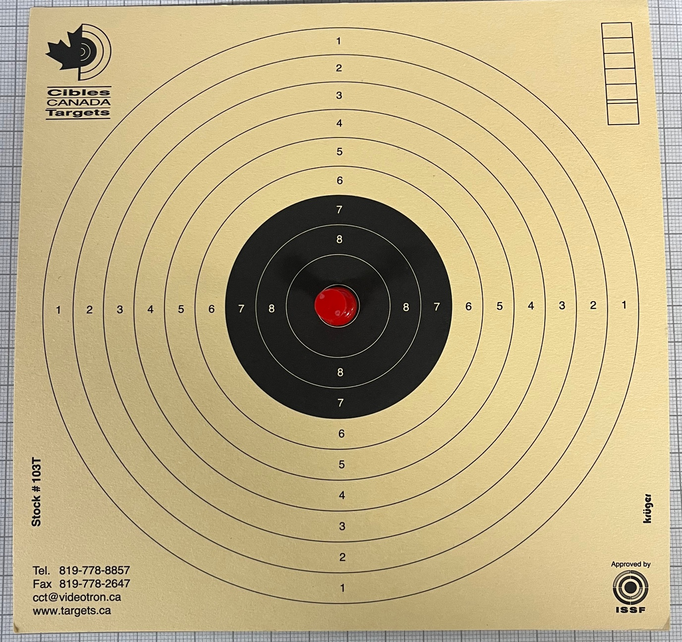
Figure A1. Graph Paper Alternative to Target. Scan

- Tape the target to the graph paper
- Attach the target and graph paper to the target as you would normally
- Shoot 10 shots into the target/graph paper
- Change to a second target/graph paper and repeat
- Carefully locate the centere of each pellet hole
- Write down the X-Y coordinates of each centrepoint
- Use these coordinates for the {“CAL”:2… } command

